**TUGAS PRATIKUM 4**

**WEB PROGRAMMING 2**



Disusun Oleh :

Nama : Azam Putra Imanto

NIM : 18090011

Kelas : 5C

Prodi : DIV Teknik Informatika

Dosen : Dwi Intan Af'idah, M.Kom.

k

**DIV TEKNIK INFORMATIKA**

**POLITEKNIK HARAPAN BERSAMA TEGAL**

**2020**

1. **Source Code**

web.php 🡪 application/controllers

v_header.php 🡪 application/views

v_index.php 🡪 application/views

v_about.php🡪 application/views

v_footer.php 🡪 application/views

stylebuku.css 🡪 assets/css1

1. **URL**

<http://localhost/pustaka_booking_azam/web>

[http://localhost/pustaka_booking_azam/web](http://localhost/pustaka_booking_azam/index.php/web)/about

1. **Capture Hasil**

Web

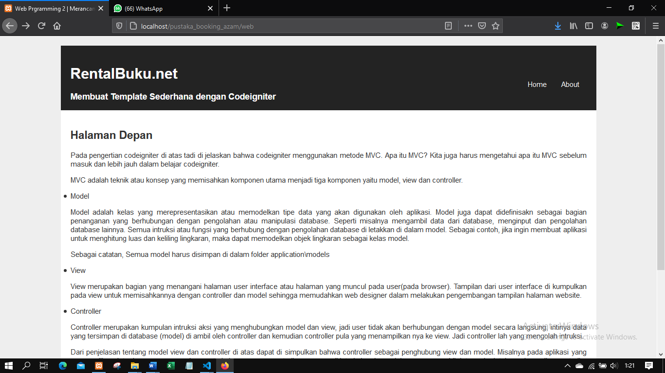

About

